Friday 27th March

Hello everyone! I hope you are all well and are taking care of yourselves. I have loved seeing all the home learning that you have been uploading. It has put a smile on my face but has made me miss seeing you all at school too.

It has been lovely to enjoy the sunshine over the last couple of days and the kittens and I have spent lots of time in the garden doing outdoor exercise and painting the garden fence.

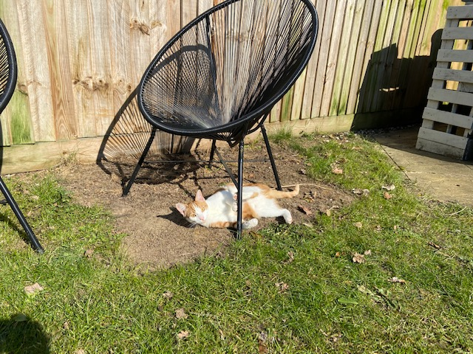 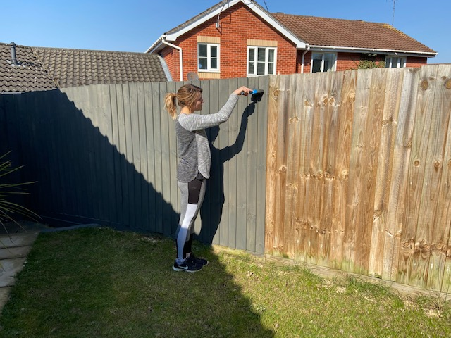

I have been doing lots of baking in the afternoons and have made cakes to send to my family over the weekend. I have been trying hard to not eat too many of these myself.

Keep sending in your home learning and keep smiling.

I will speak to you soon.

Love Miss Bridge.