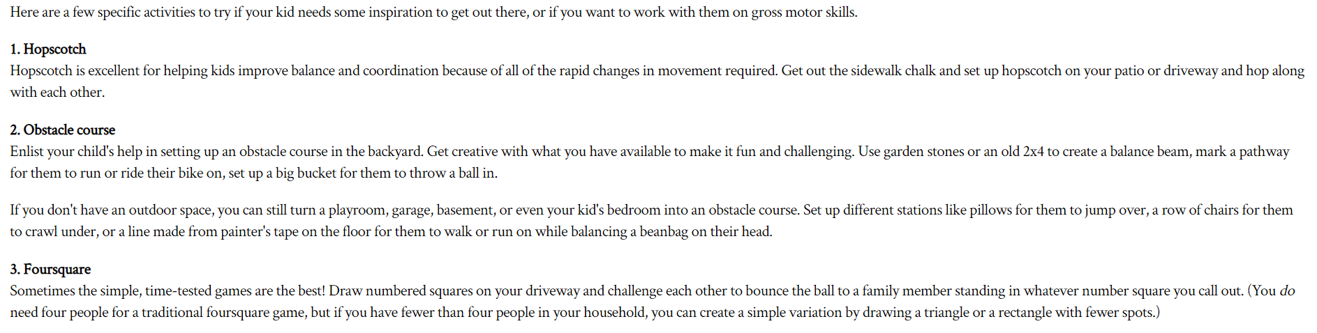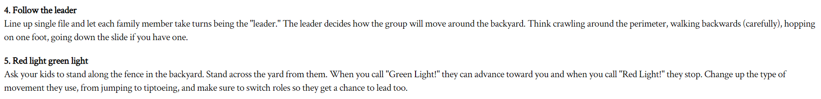**Gross Motor Skills Family Games**