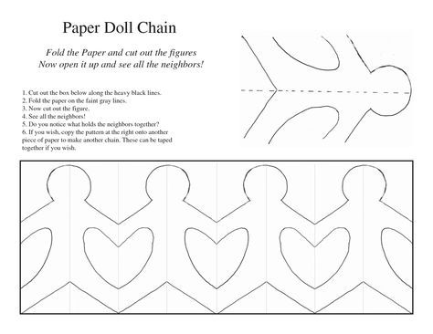
Create your very own paper chain of adorable little gingerbread men using this handy resource as a template! Simply concertina the paper by folding it back on itself repeatedly, then cut around the shape of the gingerbread man.

