Monday 13th April 2020
Hello everyone,
I hope you all had a lovely Easter weekend and the Easter bunny was able to visit you all and bring you some yummy chocolate treats!
We were blessed with some wonderful sunshine so we spent lots of time in the garden. The Easter bunny left some little eggs in our garden, which was a lovely treat for us all.
Over the Easter weekend, my children and I decorated some little chicks using eggs box cartons. We painted them and stuck on little orange beaks and feathers. We also made bird feeders out of milk bottle cartons and tied them to the tree branches.
Take a look, maybe you could have a try making these.
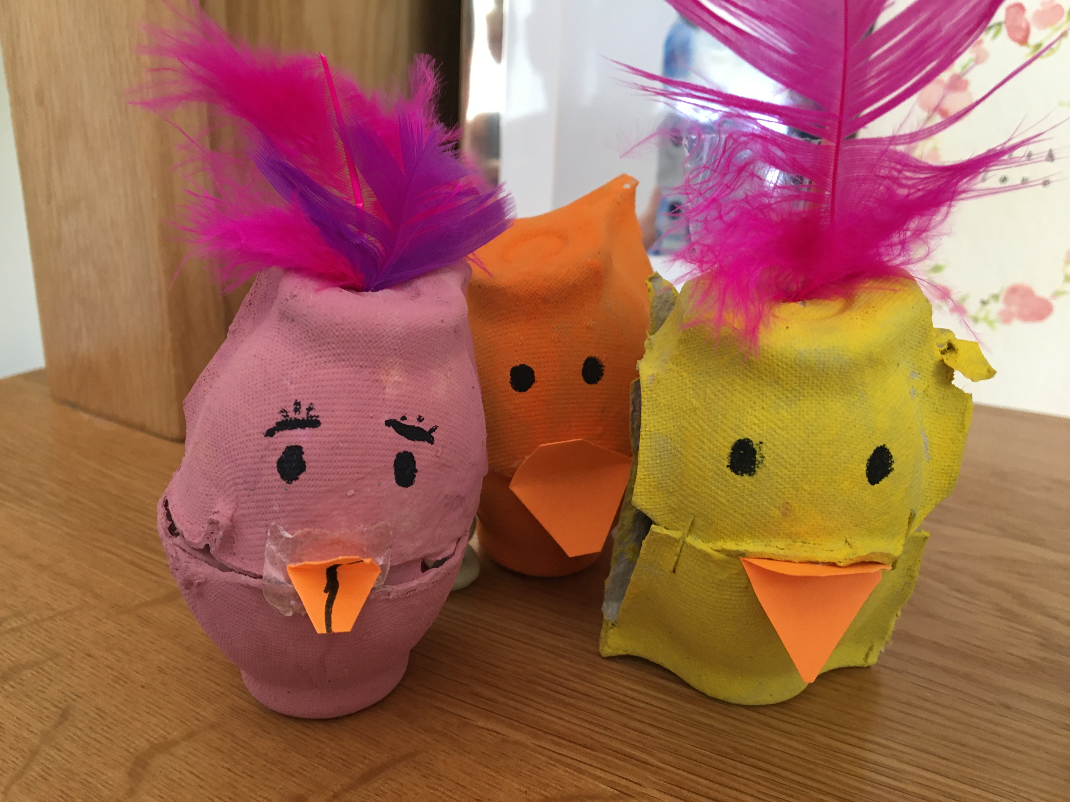
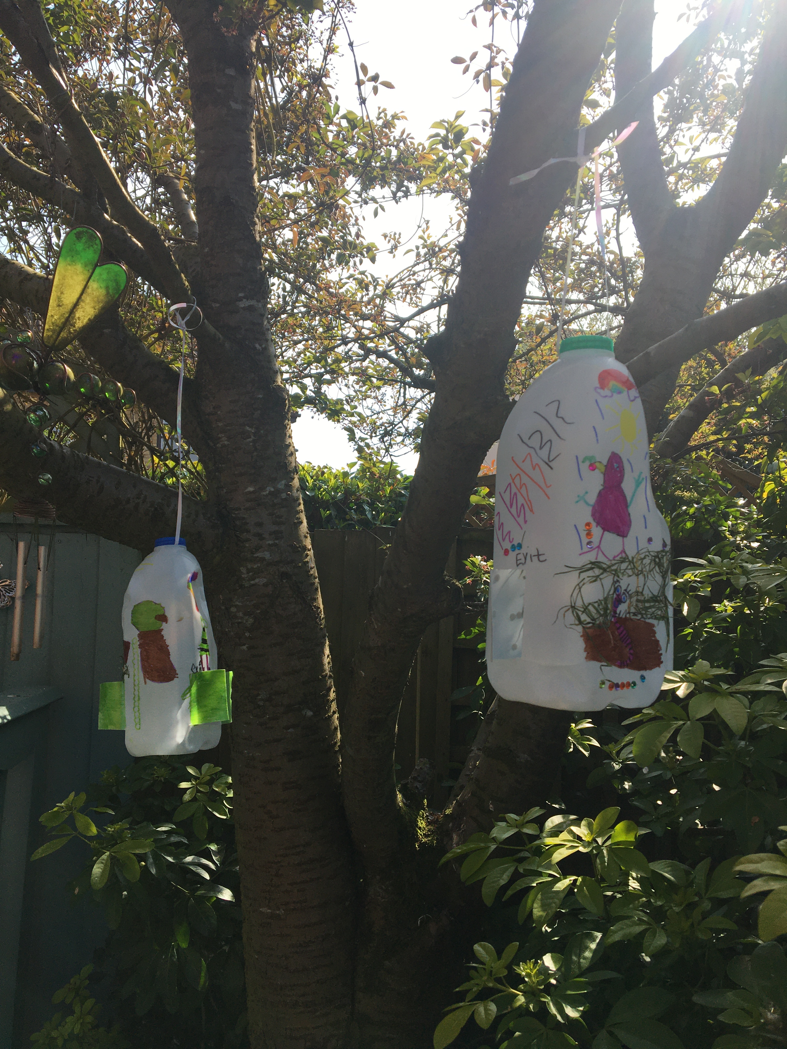
Have a lovely week everyone. Keep up the good work and keep smiling.

Don’t forget to send any of your work into homelearning@st-edmunds.suffolk.sch.uk
I have really enjoyed seeing some of your work.

Take care,
Mrs Martin

