Honey Cake *James Martin

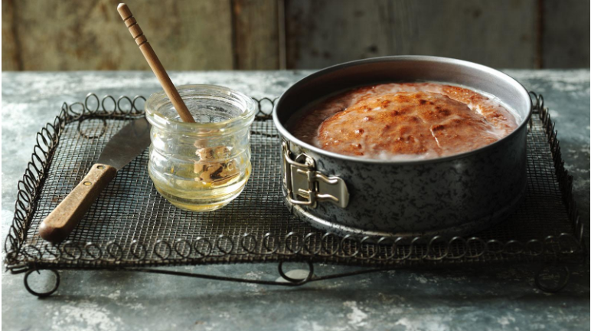
Ingredients
- 170g/6oz clear honey
- 140g/5oz butter
- 85g/3oz light muscovado sugar
- 2 eggs, beaten
- 200g/7oz self raising flour, sieved
- water

For the icing
- 55g/2oz icing sugar
- 1 tbsp clear honey
- hot water

Method
- Preheat oven to 180C/350F/Gas 3 and butter and line the bottom of a 7in/18cm cake tin.
- Measure the honey, butter and sugar into a large pan. Add a tablespoon of water and heat gently until melted.
- Remove from the heat and mix in the eggs and flour.
- Spoon into the cake tin and bake for 40-45 minutes until the cake is springy to the touch and shrinking slightly from the sides of the tin.
- Cool slightly in the tin before turning out onto a wire rack.
- While the cake is still warm, make the icing by mixing the sugar and honey together with 2-3 teaspoons of hot water. Trickle over the cake in whatever design takes your fancy.

