**Kampong Ayer Resources**

Kampong Ayer Satellite Image

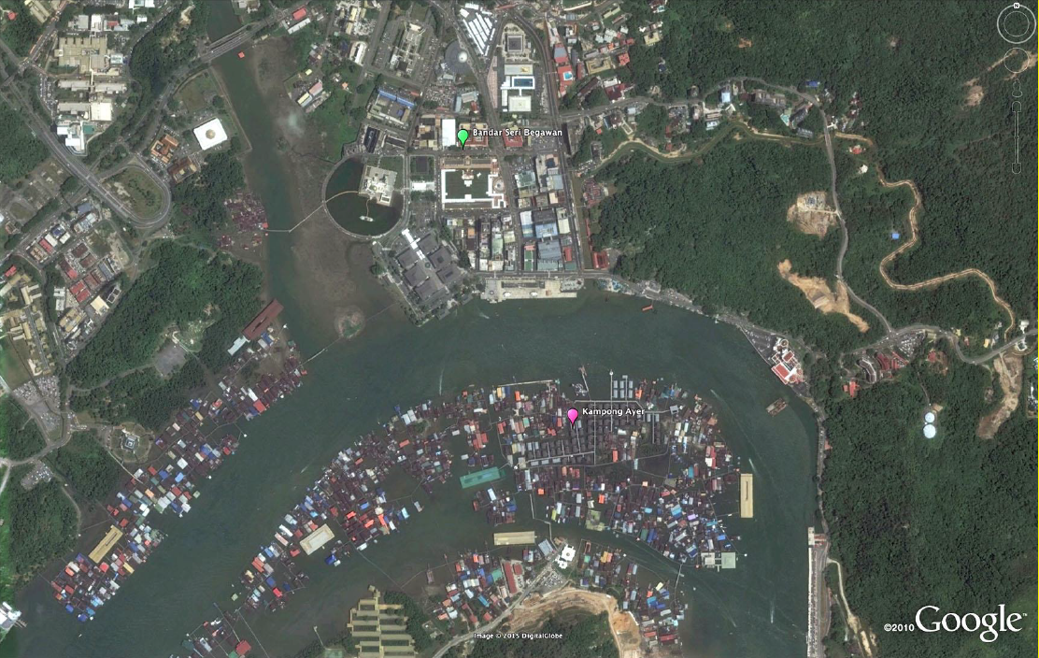

Crossing the River

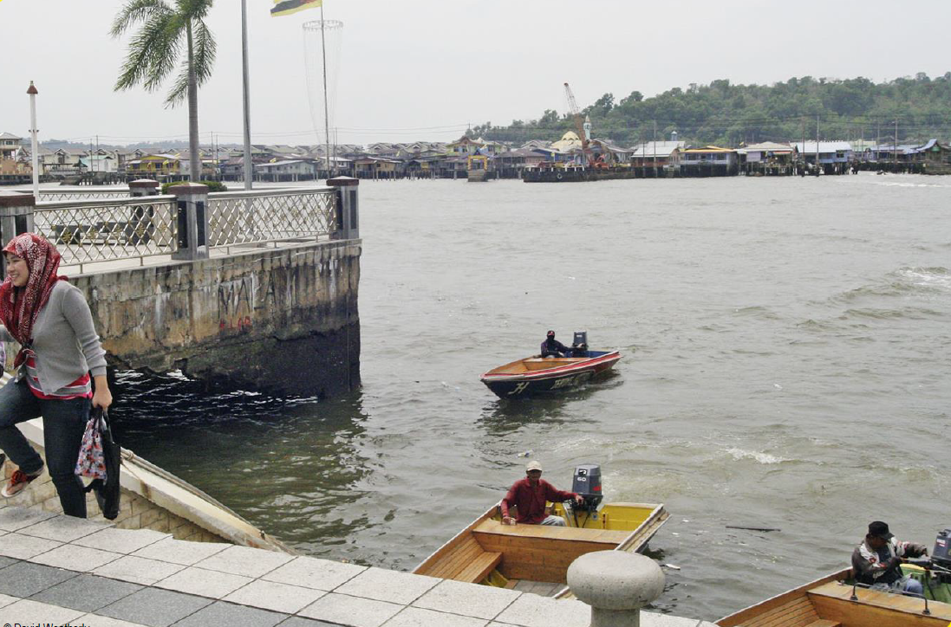

Making Boats

|  |  |
| --- | --- |
|  |  |

|  |  |
| --- | --- |
| *Temuai* boat |  |

Boat Designs

