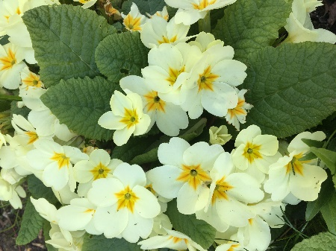 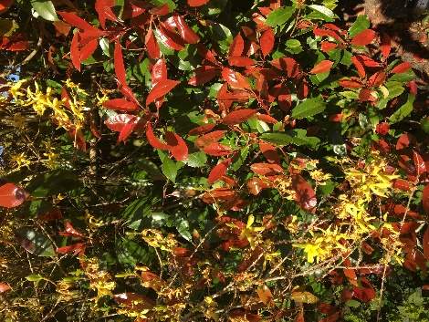 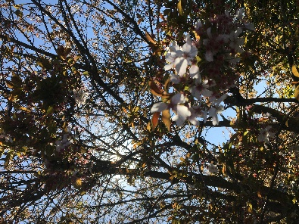

**Art**

Spring is well and truly upon us.

I have enjoyed getting some fresh air in the garden and looking at all the beautiful plants and flowers.

Can you spot all of the colours and the different shapes?

Look in your garden or through the window and draw/paint/collage what you see.

You can be as creative as you like. We would love to see some of your pictures. Happy learning.

[homelearning@st-edmunds.suffolk.sch.uk](mailto:homelearning@st-edmunds.suffolk.sch.uk)

Mrs Martin and the Year 2 team.

