Monday 8th June 2020
Hello everyone,
How are you all? It was lovely to see some of your home learning last week and see how well you are doing and how hard you are working at home. Please remember to try to email something you have done to homelearning@st-edmunds.suffolk.sch.uk. It always puts a smile on my face to see what you have been up to.
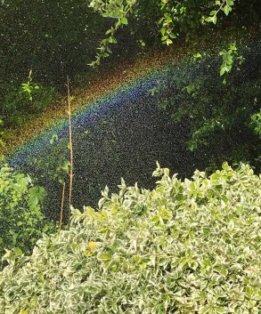
There was an activity booklet about Rainbows on the year 2 page last week so it was very fitting when I received this beautiful photo from my parents. When I showed my children, they thought that fairies had been in nanna and grandad’s garden!
Can you spot all of the colours?

We had a few cooler days last week so I spent some time in the kitchen doing some baking with my children. We made scones, blueberry and banana muffins and sausage rolls. We talked about recipes, measuring ingredients and fractions too! Unfortunately, there are no photos as they were all eaten very quickly! Maybe you could do some baking, write out the recipe and send it in. I would love to see what you make!
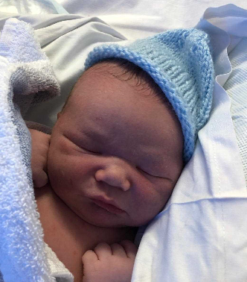
I have spoken to Mrs Hudelson who is doing well and enjoying lots of cuddles with her new baby Thomas. She said she is very tired but loving being at home and looking after him.
Take care,
Love from Mrs Martin

